Introduction
Four years after its passage, and months after several of its most significant components went into effect, the Affordable Care Act (ACA) has significantly affected survey respondents across the nation. While uncertainty about the long-term impact of the ACA remains, employers are starting to observe and measure the impact of the law in their workplaces. When faced with the prospect of providing coverage for employees or paying a fine, a large majority of employers decided to “play.” Of those, most are now reporting increased costs. Employers also remain largely skeptical about other aspects of the law, including the health insurance Exchanges and the community rating requirements.
However, respondents are also reporting more comfort with the law, with higher levels of confidence in understanding, complying with and administering the law in their workplaces. Two-thirds of respondents are confident they are now in compliance with ACA guidelines, and a number of their concerns have subsided dramatically over the past two years. The number of respondents reporting that broker services are very important for ACA education and assistance has continued to rise over the past three years—many rely directly on their brokers to provide these essential services. Keep an eye out for further increases in these numbers should there be additional changes in the law.
The 2014 Affordable Care Survey was conducted in early 2014 and was available to individuals through client portal websites. A total of 2,060 respondents completed the survey.

Table of Contents
Demographics 3
Broker-provided Services 4
Health Plans 6
Pay or Play Decision 7
Costs 8
Compliance 9
Health Insurance Exchanges 10
SHOP Exchanges 11
Early Renewal 12
Community Rating Restrictions 13
Workplace Wellness 14
Cadillac Plans 15
Health Care Reform Administration 16
Overall Changes 17

Demographics
How many employees does your organization employ? 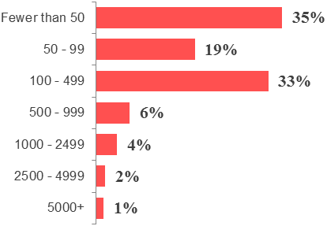
What is your organization's annual revenue? 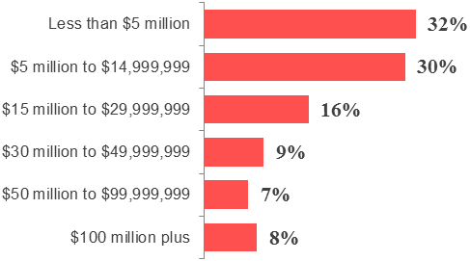

In which region is your organization based (the most employees)?

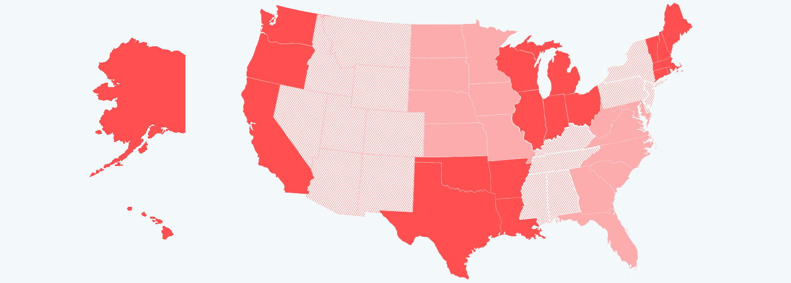
In which industry/sector does your organization operate? 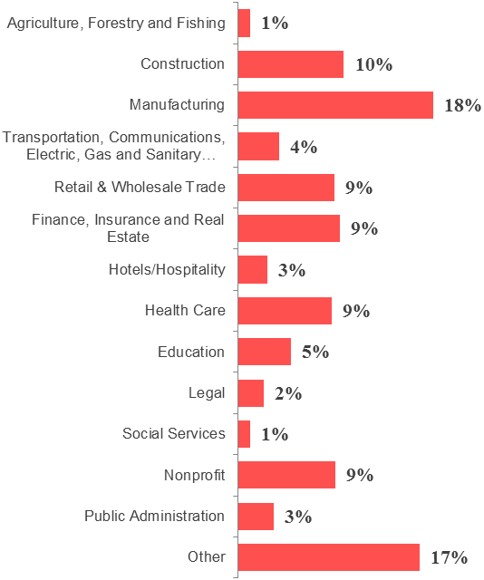

11%
9%
14%
9%
19%
5%
15%
10%
This survey was completed by employers in all 50 states and the District of Columbia. Similar to 2013, the overwhelming majority of survey respondents were from organizations employing fewer than 500 employees.
Broker-provided Services
How important is it that your benefits broker provides your organization the following services with respect to health care reform?
 | Very Important | Important | Slightly Important | Not Important
Offering legislative updates to educate on the Affordable Care Act and its implications | 71% | 23% | 4% | 2%
Offering educational seminars about the Affordable Care Act and its implications | 52% | 32% | 13% | 4%
Modeling the financial impact of the Affordable Care Act, including possible penalties, on your organization | 64% | 27% | 6% | 3%
Helping educate employees on the Affordable Care Act reforms and their implications | 44% | 38% | 14% | 4%
Helping develop a health benefit strategy and multi-year implementation plan for active employees | 51% | 33% | 12% | 3%
Providing decision support tools to help employees evaluate their options | 44% | 39% | 14% | 4%
Helping adopt and implement a consumer-driven health plan (CDHP) to drive down costs | 32% | 35% | 23% | 10%
Helping implement workforce health improvement / wellness initiatives | 30% | 36% | 25% | 9%
Helping prepare the Summary of Benefits and Coverage | 66% | 25% | 6% | 3%

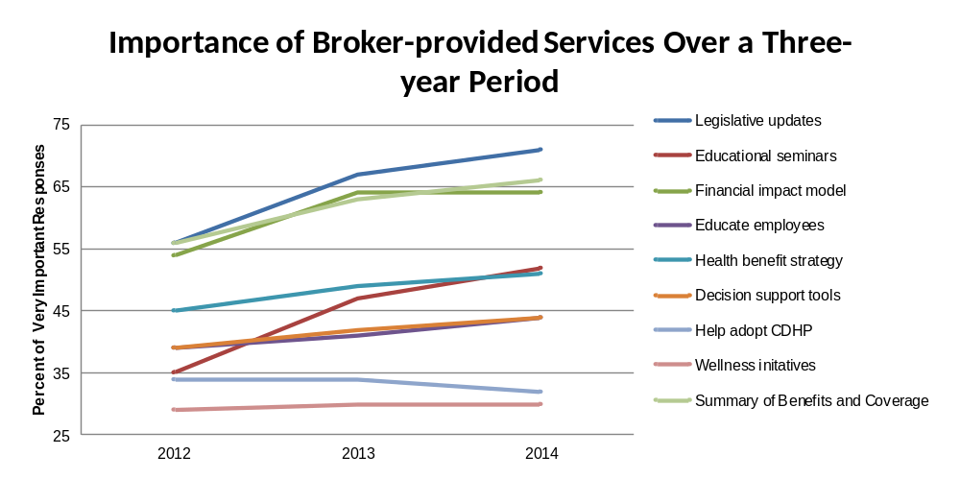

Do you find value in the Affordable Care Act resources available on your insurance broker portal? 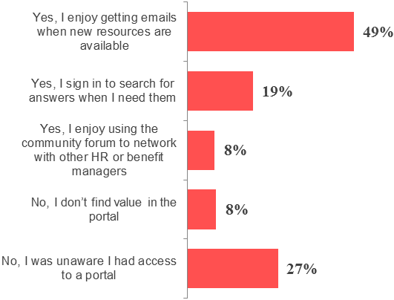

When you have a question regarding the Affordable Care Act, where do you turn? 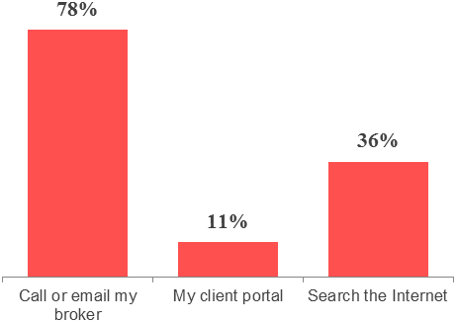

Which services, with respect to the Affordable Care Act, is your broker currently providing?

 | Not Providing | Partially Providing | Fully Providing
Offering legislative updates to educate on the Affordable Care Act and its implications | 8% | 24% | 68%
Offering educational seminars about the Affordable Care Act and its implications | 18% | 33% | 49%
Modeling the financial impact of the Affordable Care Act, including possible penalties, on your organization | 20% | 37% | 43%
Helping educate employees on the Affordable Care Act reforms and their implications | 28% | 39% | 33%
Helping develop a health benefit strategy and multi-year implementation plan for active employees | 31% | 37% | 32%
Providing decision support tools to help employees evaluate their options | 34% | 36% | 30%
Helping adopt and implement a consumer-driven health plan (CDHP) to drive down costs | 43% | 31% | 26%
Helping implement workforce health improvement / wellness initiatives | 36% | 38% | 26%
Helping prepare the Summary of Benefits and Coverage | 14% | 24% | 62%

Health Plans
Do you plan to make any changes to the funding mechanism for your primary health plan in the next year? 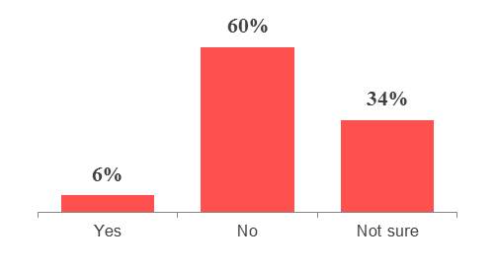

How is your largest group health plan funded? 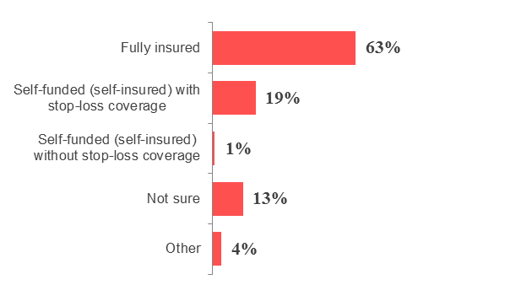

Which active employees are offered coverage under your organization's health plans? 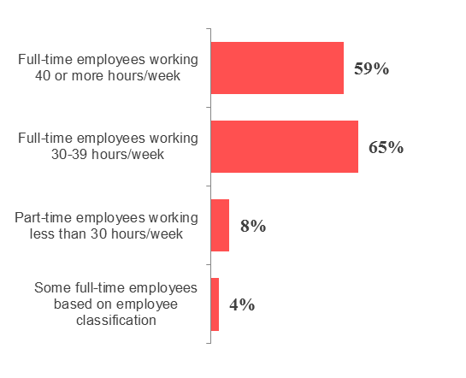

The number of respondents saying they are sure they will make no changes to their health plans’ funding mechanism in the next year fell by 26 percentage points. Underscoring the newfound uncertainity, the number of respondents who answered yes fell to single digits for the first time since the survey was first offered in 2012.
Additionally, the number of employers that are offering health coverage to employees working 40 hours or more per week fell by five percentage points from 2013, while the number offering coverage to employees working 30 to 39 hours a week increased by two points.
What types of health plans does your organization currently offer?
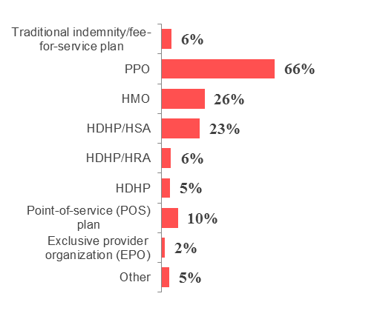
Pay or Play Decision
In 2015, employers with more than 50 employees are required to offer minimal essential health coverage to employees or be subject to a penalty. How likely is your organization to continue offering health benefit coverage to your employees once this requirement kicks in? 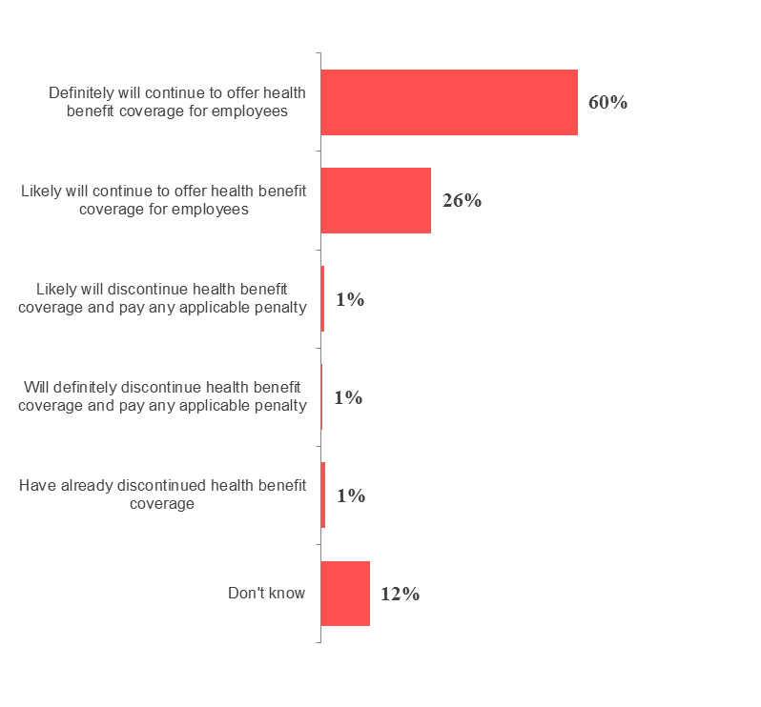
If you plan to keep coverage, what are your reasons for doing so? 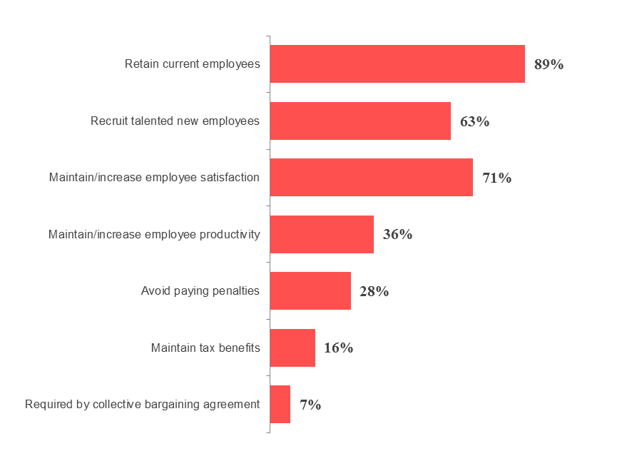
If you plan to discontinue coverage, what are your reasons for doing so? 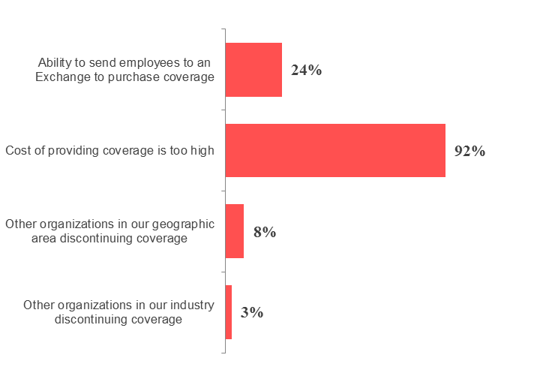
In 2015, employers with 50 or more full-time equivalent employees are required to offer affordable, minimum value health coverage to full-time employees or possibly pay a penalty. The number of organizations planning to continue offering health coverage to employees once this requirement takes effect increased nine percentage points over the last two years, while the percentage of employers that are unsure or chose a discontinue option has dropped from 25 percent to 15 percent of total respondents.

NOTE: While the responses to the 2014 Affordable Care Act Survey were being collected, the final pay or play regulations that announced the delay for medium-sized employers were released. This delay means that some employers will not have to offer coverage until 2016.
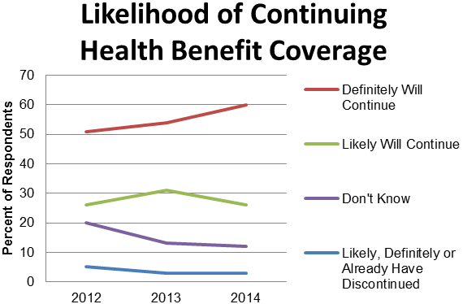

Costs
Nearly 7 in 10 respondents said that ACA changes have increased their organization’s health benefits costs or that they are expecting future increases, down eight percentage points from two years ago. More than 6 in 10 respondents say they are passing costs along to their employees, and 4 in 10 say they are reducing health benefits and programs. One-third of respondents are absorbing some of the increased costs themselves. Other responses included changing health insurance carriers, reducing part-time hours and remaining undecided.
Have the changes required by the Affordable Care Act increased your organization's health benefit costs or do you expect them to do so in the future? 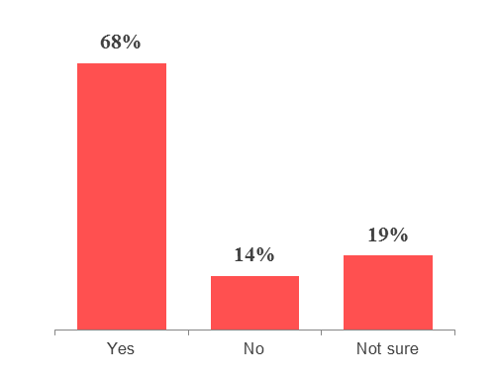

What are the actions your organization has taken/plans to take in response to increased health benefit costs caused by the Affordable Care Act? 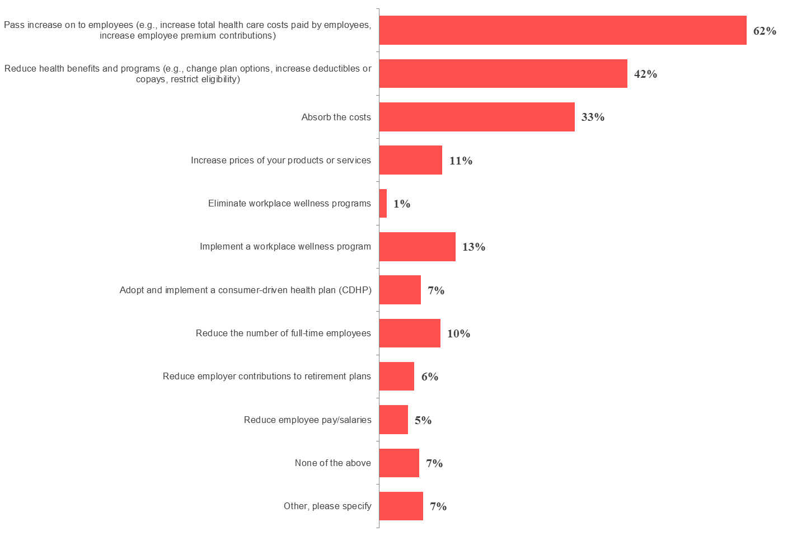

Compliance
How certain are you that your organization is currently in compliance with the Affordable Care Act's effective provisions? 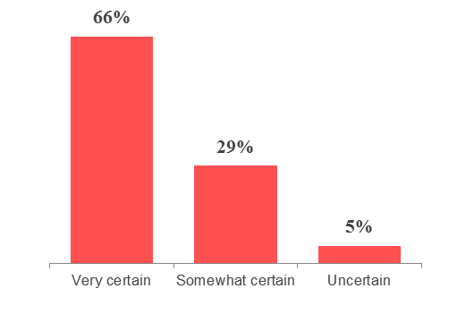

How prepared do you consider your organization to be for compliance with future Affordable Care Act provisions? 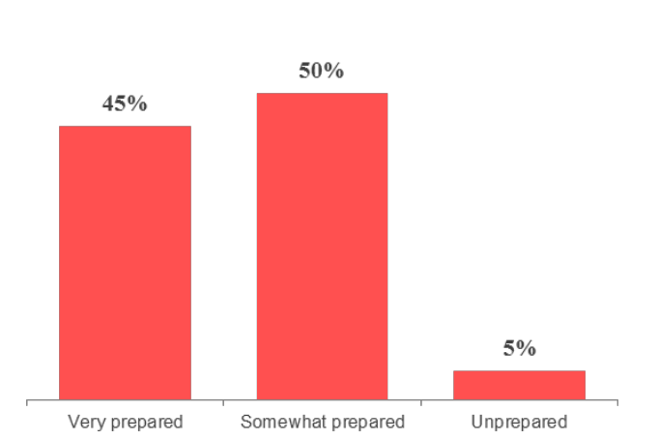
Employers’ confidence in their ability to comply with ACA provisions has skyrocketed since 2013, as two-thirds of respondents indicate they are very certain they are complying—a 21-point gain. The number of respondents signaling they are very confident they can comply with future ACA provisions increased by a similar amount (19 points) but still remains under the 50 percent mark.
Health Insurance Exchanges
What is your organization's overall attitude toward the state-run or federally run individual health insurance marketplaces as an option for your employees? 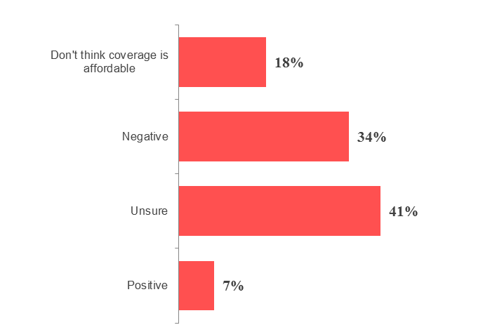

Are you considering moving to a private exchange in the next three to five years?
86% | No
Yes |  | 14%

Following the rollout of the Exchanges, most employers remain unsure or skeptical about the Exchanges’ value. The number of respondents who view the Exchanges negatively remained virtually identical to 2013, while the number who think Exchange coverage is unaffordable doubled. Four in 10 respondents remain unsure of their value, and less than 10 percent have a positive view of the Exchanges at this time.
Moreover, less than one-fifth of respondents offer health benefits through a private Exchange or are considering moving to a private Exchange in the next three to five years. Of the 12 percent of respondents who do use a private Exchange, only 6 percent said they have seen a decrease in their health care costs.

Do you currently use a private exchange to provide benefits to your active employees or retirees?
88% | No
Yes |  | 12%

Have you experienced a decrease in health care costs since moving to a private exchange? 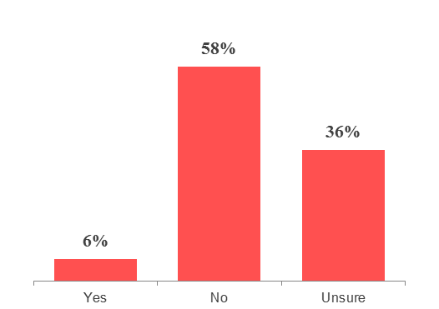

SHOP Exchanges
Many respondents are reluctant to use, or are unsure about using, the Small Business Health Options Program (SHOP) Exchange. Over half of respondents are currently shut out from the SHOP Exchanges, unable to meet eligibility requirements. Of those whose companies are eligible, 38 percent of respondents are unlikely or very unlikely to purchase coverage through a SHOP Exchange in the future, compared to 15 percent who are likely to use a SHOP Exchange or already have. When asked how they would go about selecting coverage through SHOP, two-thirds of employers preferred to use a broker.

Are you eligible to provide coverage through the Small Business Health Options Program (SHOP)? Eligibility requirements generally include having up to 50 employees. 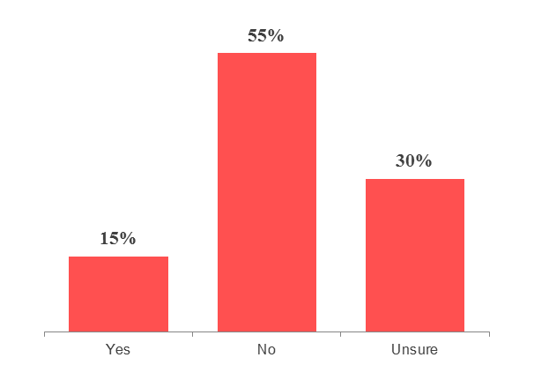

If purchasing coverage through the SHOP in the future, how would you prefer to select and offer a plan? 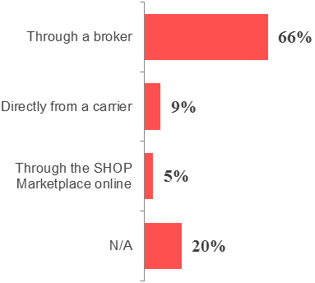

If you are eligible to provide coverage through a SHOP, how likely are you to do so? 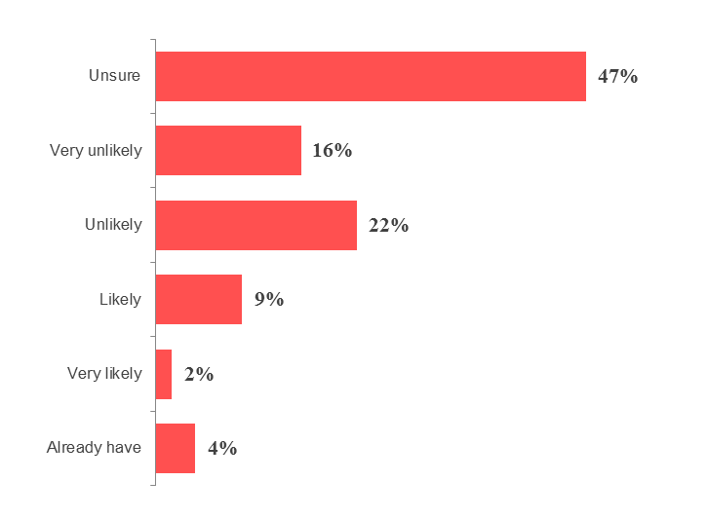

Early Renewal
When asked whether they were offered an early renewal option through their carriers in 2014, the largest block of respondents (43 percent) said no. But of the 33 percent who were given the option, nearly 60 percent chose to renew early. Some carriers have offered an early renewal option for 2015 as well, but as of this writing, only five percent of respondents have been offered such an option.
Did your organization's carrier offer an early renewal option for 2014? 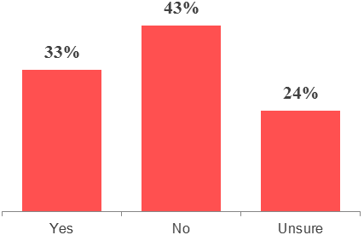

Has your organization's carrier offered an early renewal option for 2015? 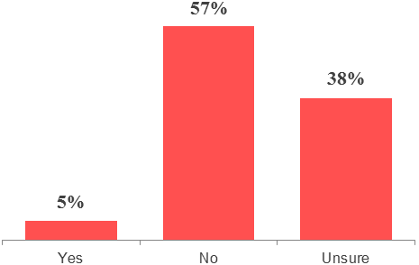

If your organization was offered a renewal in 2014, did your organization take advantage of an early renewal option? 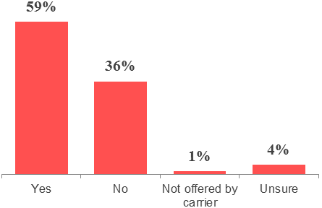

Community Rating Restrictions
As expected, almost 4 in 10 respondents say community rating restrictions have increased costs or have had no effect, compared to 13 percent of respondents who said their costs have decreased or stayed the same since community rating restrictions were implemented. Roughly the same number of respondents say the same is true for the effect of community rating restrictions on the cost of health care for their employees. In both cases, a plurality of respondents are unsure of the impact of community rating restrictions on health care costs, and only 2 percent of respondents report the community rating restrictions have led to lower costs.
How have the new community rating restrictions affected the health care costs of your organization? 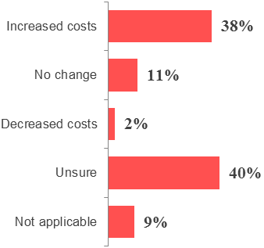

How have the new community rating restrictions affected the health care costs of your employees? 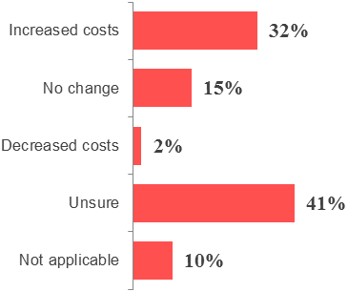

Workplace Wellness
Starting In 2014, employers are permitted to increase employee wellness program rewards or penalties to 30 percent of the cost of coverage (up from the prior limit of 20 percent). However, the number of respondents who are either likely or very likely to create or expand their wellness programs as a result of this change plummeted 24 percentage points. Even adjusting for the number of employers that say they already have implemented a wellness program, the number represents a decline in enthusiasm from previous years. Nearly half of employers now say they are unlikely or not very likely to implement a wellness program because of ACA provisions.

Since the beginning of 2014, employers have been permitted to increase employee wellness programs rewards or penalties to 30 percent of the cost of coverage (50 percent for tobacco-related programs), up from the previous limit of 20 percent. Has this prompted your organization to create or expand your workplace wellness program, or will it in the future? 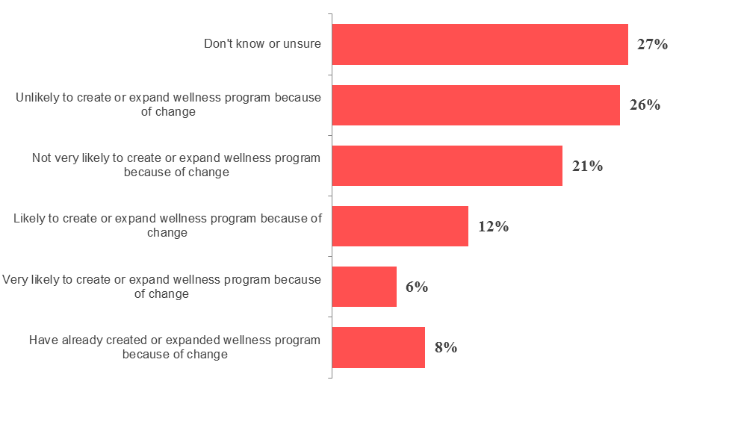

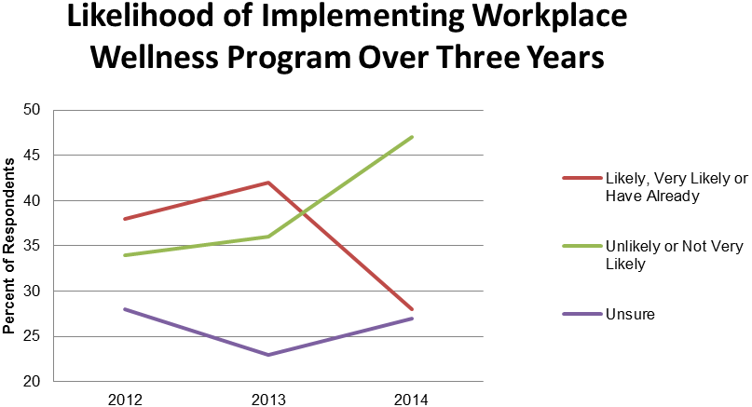

Cadillac Plans
In 2018, a 40 percent excise tax will be imposed on the excess benefit of high-cost employer-sponsored health insurance. The annual value limit for purposes of calculating the tax is $10,200 for individuals and $27,500 for other than individual coverage. What is the likelihood that your organization will need to reduce coverage to stay below these levels? 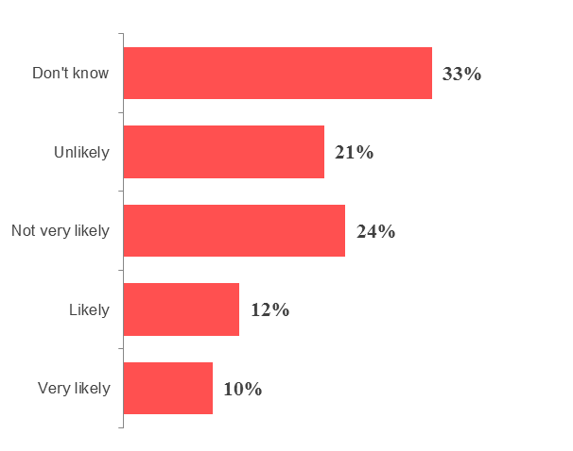

In 2018, a 40 percent excise tax will be imposed on the excess benefit on high-cost employer-sponsored health insurance. The annual value limit for purposes of calculating the tax is $10,200 for individuals and $27,500 for anything other than individual coverage.
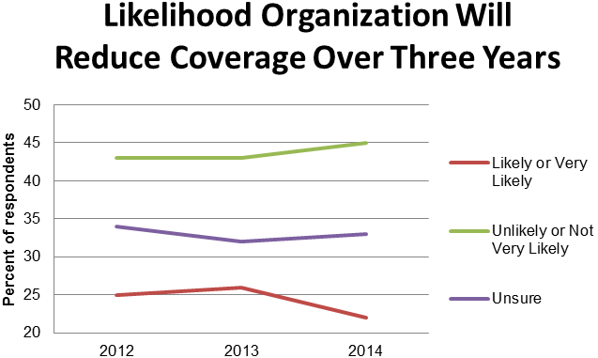

There was a slight decrease from last year to this year in respondents who stated that their organization was either very likely or likely to need to reduce coverage to stay below these levels. While still comparable to 2012 levels, the gap between the “likely” responses and “unlikely” responses is at an all-time high of 23 percentage points.
Health Care Reform Administration
Which Affordable Care Act provisions are you most concerned about implementing and administering? 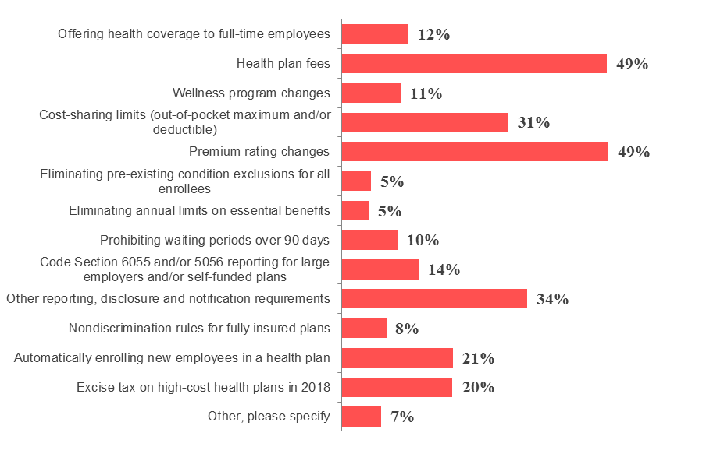

The top two health care reform provisions employers report being most concerned about are health plan fees and premium rating changes. Those options were not part of the survey in prior years. This year, just under half of respondents have concerns about these issues, while one-third of respondents are concerned about reporting, disclosure and notification requirements. Previous top concerns, including various reporting requirements, have been broken apart into several categories and may have dissipated somewhat following regulatory clarification from the federal government. Also, several employers have likely made decisions on these issues, dispelling some of their concerns. Of respondents who answered “other,” popular reasons listed included tracking employee hours and further rule changes.
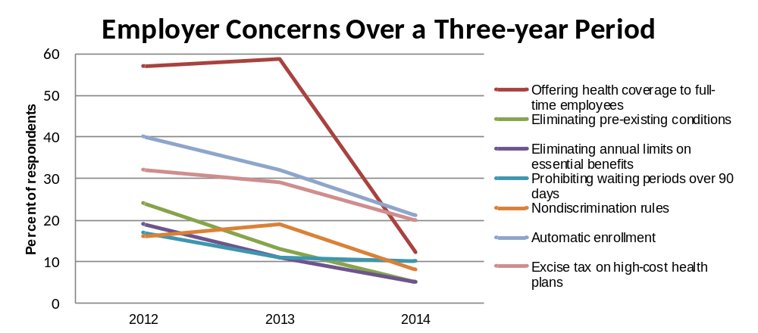

Overall Changes
Do you plan on making any of the following changes as a result of health care reform? 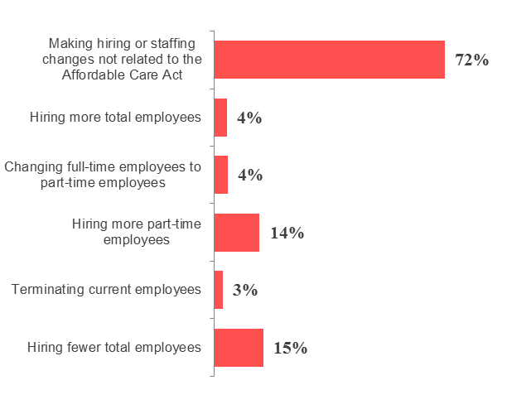
Are you considering any of the following options for 2014 or beyond? 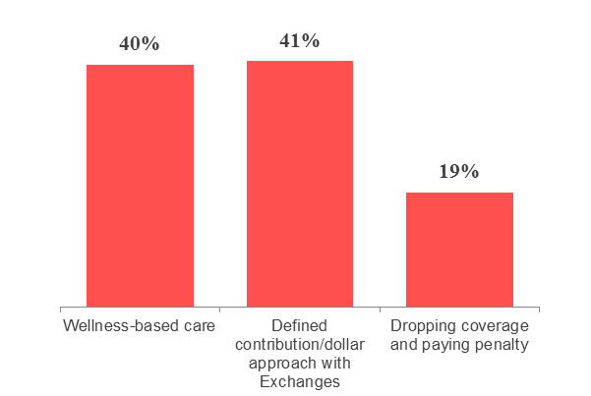
Many employers plan to make some organizational changes as a result of health care reform. From offering wellness-based care to hiring fewer total employees, health care reform is affecting organizations.
© 2014 Zywave, Inc. All rights reserved.

Contact GTPS Insurance Agency to discuss how this survey information can assist you in your future benefit plan strategies.

This survey was conducted in early 2014 through the client portal website provided by GTPS Insurance Agency. This survey was anonymous, so responses have not been validated for statistical significance or margin of error.

